Marginal Effects in Quadratic Regression Models:

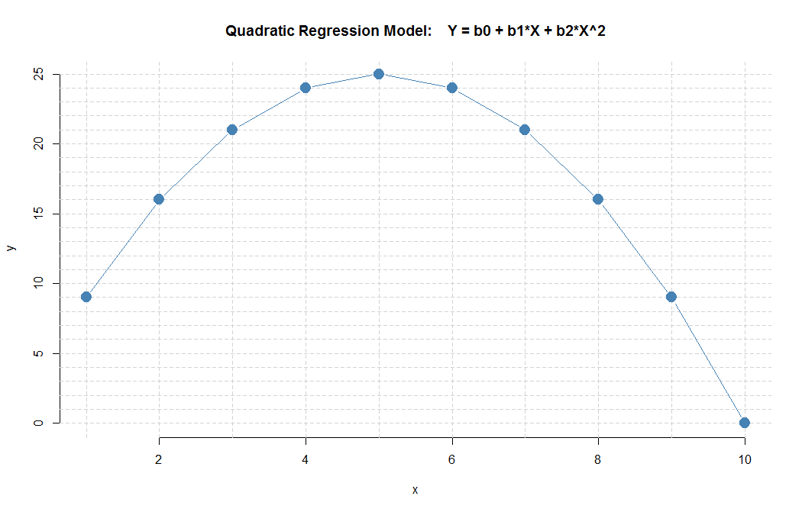

x xsq yhat
1 1 9
2 4 16
3 9 21
4 16 24
5 25 25
6 36 24
7 49 21
8 64 16
9 81 9
10 100 0

The regression model in this example has the following parameters:

$$Y = 0 + 10*X - 1*X^{2}$$

Question: what is the marginal effect (change in Y associated with one-unit change in X) at the given points:

- What is the marginal effect at X=1? What is the “slope” between X=1 and X=2?

- What is the marginal effect at X=5?

- What is the marginal effect at X=9?

